**12-659**

**SPECIAL TOPICS: MATLAB**

**Exercise 1**

**Name: Yuhang Liang Andrew ID: yuhangl**

**October 22, 2019**

Question 1

There are 8,000,000,000,000 bits in 1 terabyte.

Question 2

The decimal number for the following binary number, 1001001001, is 585.

Question 3

The decimal number for the following hexadecimal number, 0d55c1, is 873921.

Question 4

For this question, I created the target vector in Matlab. The following screenshot is my answer.

Figure.1. Answer to Question4

Question 5

For this question, I created the target matrix in Matlab. The following screenshot is my answer.

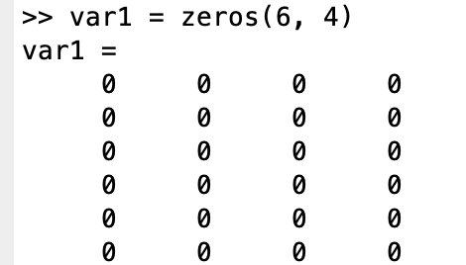

Figure.2. Answer to Question5

Question 6

For this question, I created the target matrix in Matlab. The following screenshot is my answer.

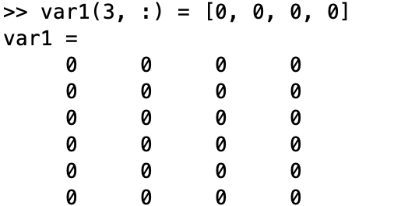

Figure.3. Answer to Question6

In this question, the matrix we want to replace is actually zeros; therefore, the values of the third row are still zeros after the change according to the question.

Question 7

For this question, I created the target matrix in Matlab. The following screenshot is my answer.

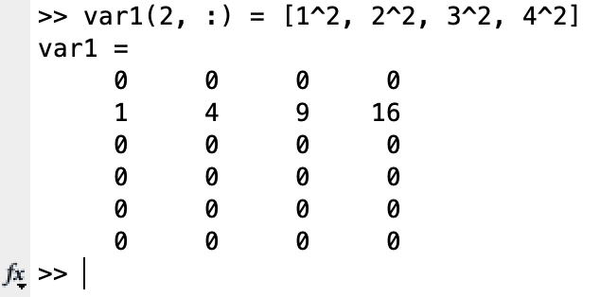

Figure.4. Answer to Question7

Question 8

For this question, I created the target matrix in Matlab. The following screenshot is my answer.

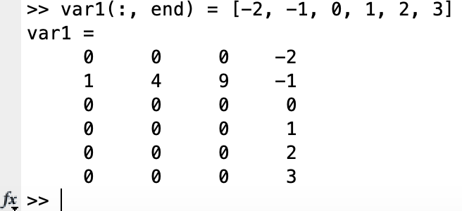

Figure.5. Answer to Question8

Question 9

There are several ways to deal with this question interactively. Firstly, to save all workspace variables to a MAT-file, on the Home tab, in the Variable section, click Save Workspace. Secondly, we also can save workspace variables programmatically using the save function. For example, to save all current workspace variables to the file exercise1.mat, use the command: save(‘exercise1’).

Question 10

**rand**: Forming a data structure composed of random numbers. The example is shown as following.

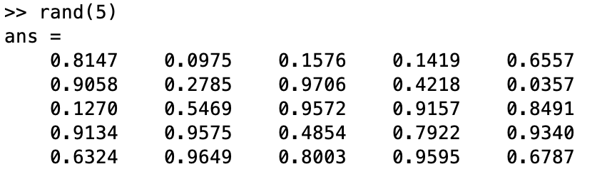

Figure.6. The example1 of Question 10

**ones:** Forming a data structure composed of all ones. The example is shown as following.

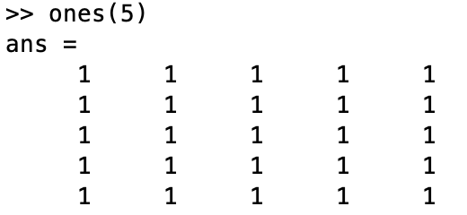

Figure.7. The example2 of Question 10

**zeros:** this function can create array of all zeros. The example is shown as following.

Figure.8. The example3 of Question 10

The things I do not understand

1. How to quickly script specific commands in the command line window?
2. How to manage the variables of the workspace reasonably?